Lab 10: File search based on metadata
What You Need for this lab
  - Install Virtualbox : https://www.virtualbox.org/wiki/Downloads
  - Install Kali 2021.4. : https://old.kali.org/kali-images/kali-2021.4/
    - Notes: Suggest You configure the disk size of Kali VM 80G because the size of each leakage cases image is 30G+
- A USB image
https://www.dropbox.com/s/a0lhsmzeh68wk1i/NTFS.001

Step 1.
- Create a working folder
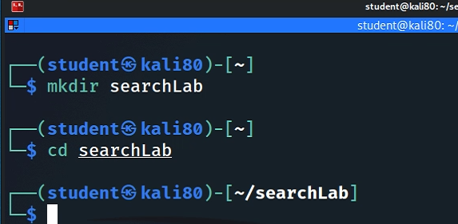
- Download a USB image
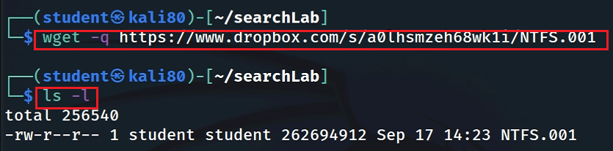
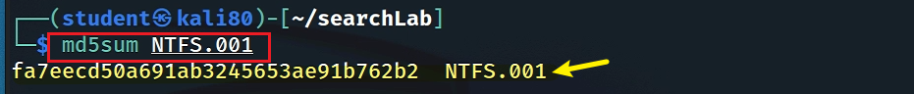
- Show image information
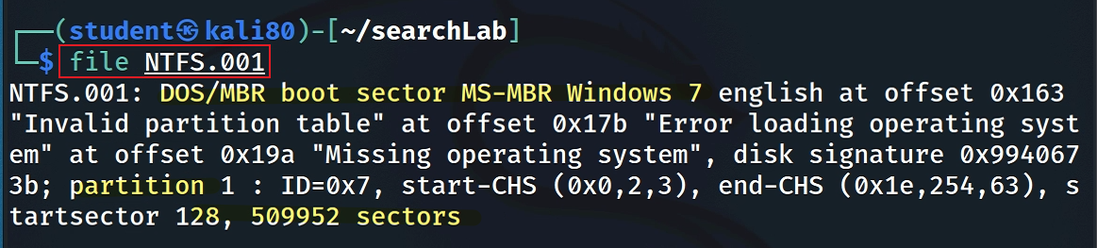
Step 2.
Mount the USB to Linux as a read-only loop device
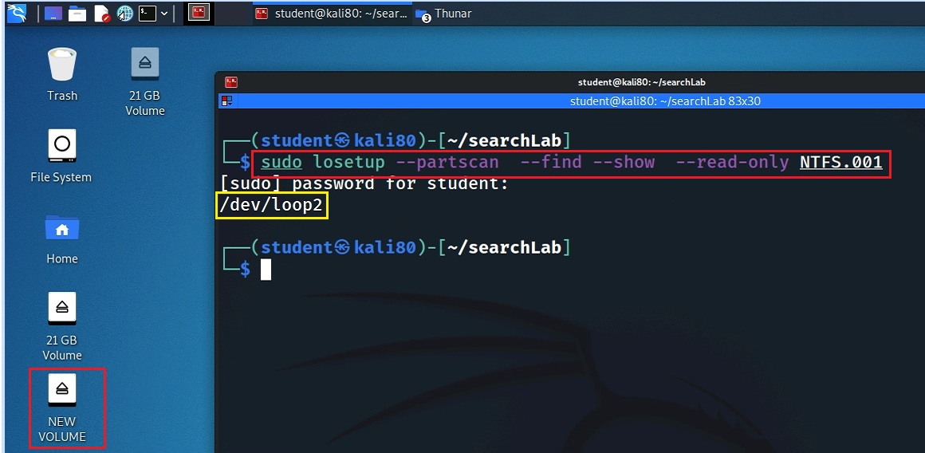
- View file structure
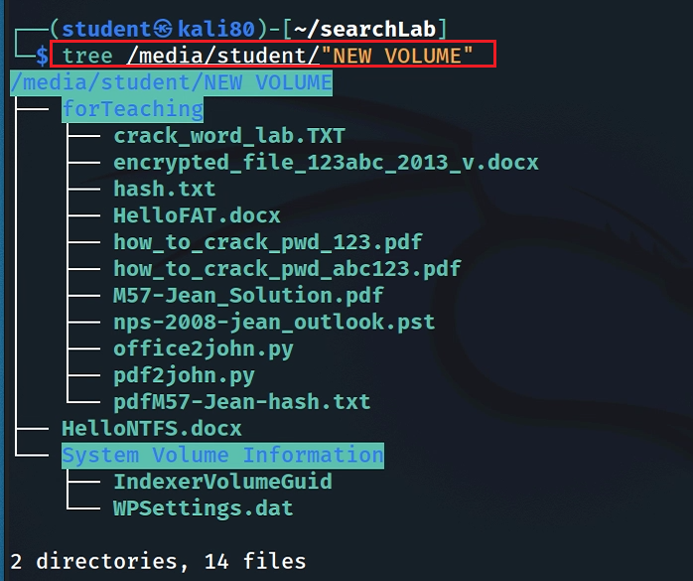
- Syntax
$ find [where to start searching from] [expression determines what to find]
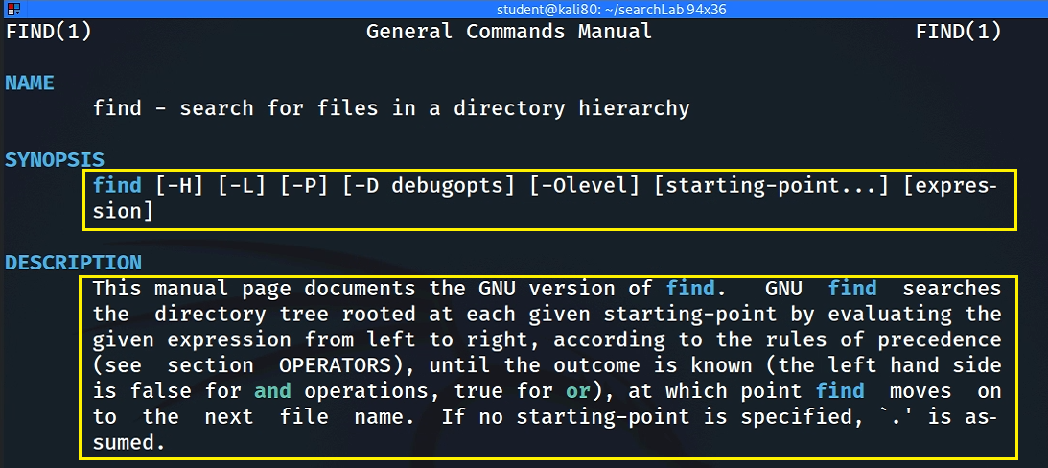
- Find Files/directories starts from Current Directory (recursively)
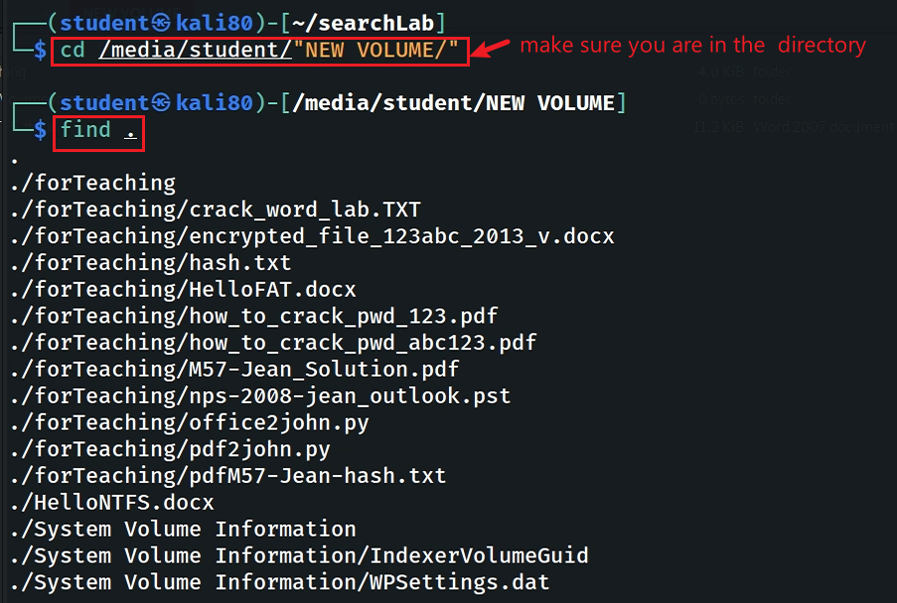
-name and -iname: find file/directory names
- find a file
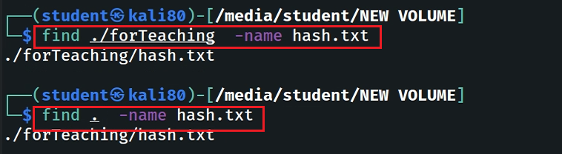
- find a file and ignore case
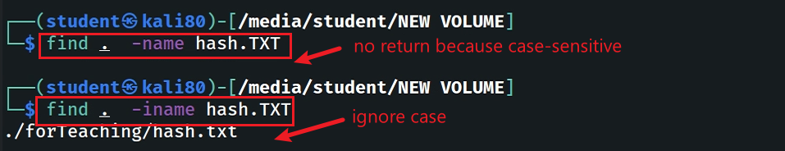
- find a directory
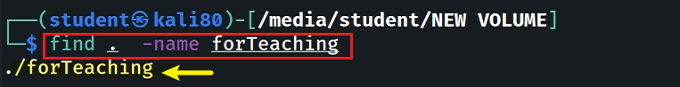
type: specify string types
- Specify the search type d: directory
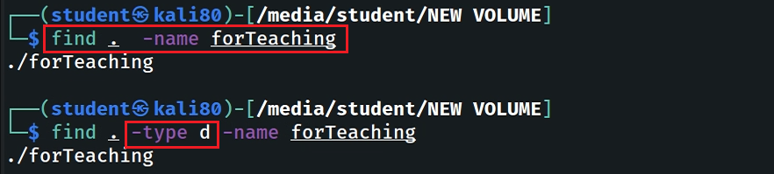
- Specify the search type f: file
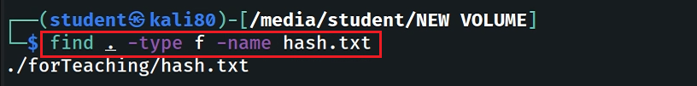
- Search all files with extension .txt
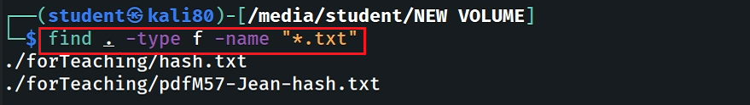
- Match all files which first and four letters are “h”
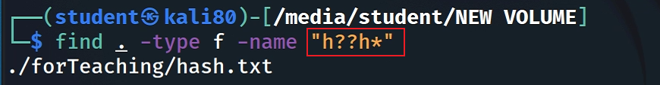
- Match all files contains “123” (in the middle of the file name)
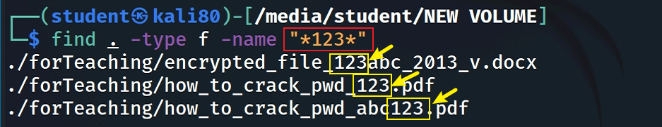
- Find Files With 777 Permissions
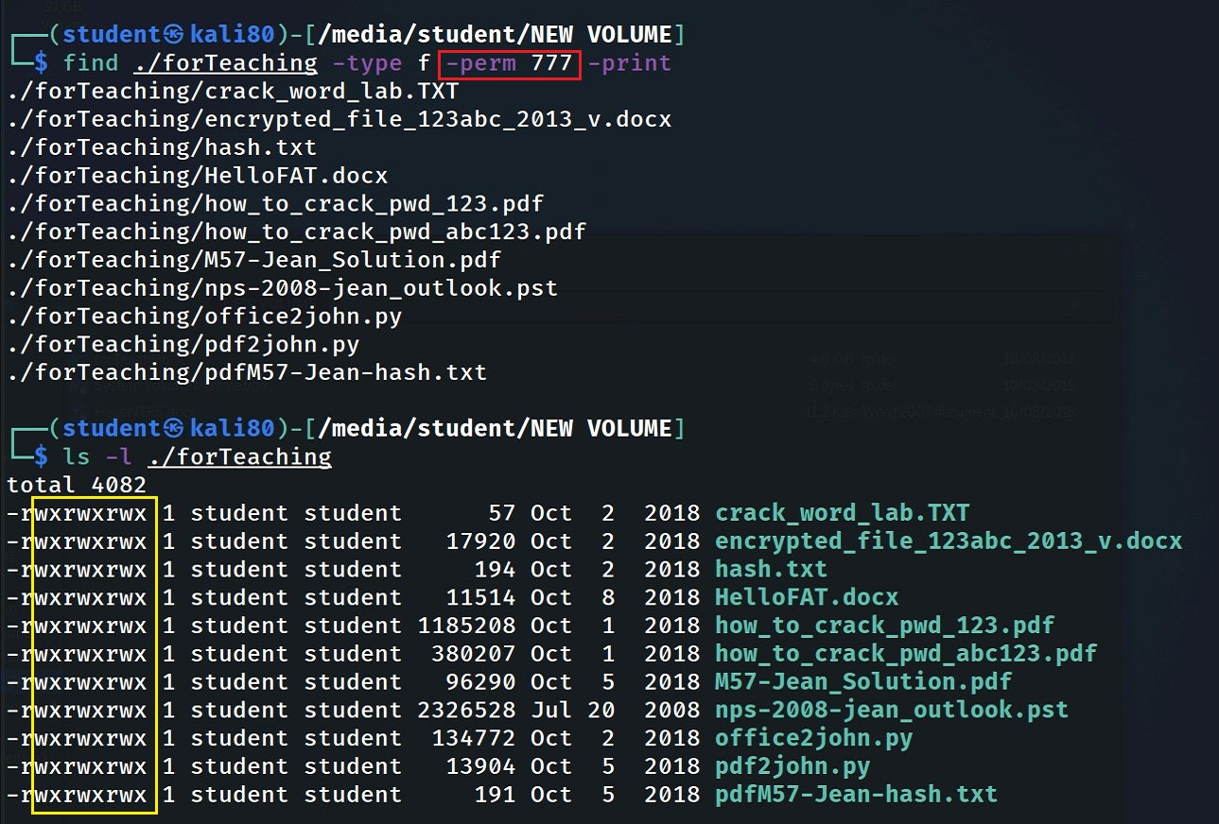
Step 3.
- “atime”, “mtime” and “ctime”
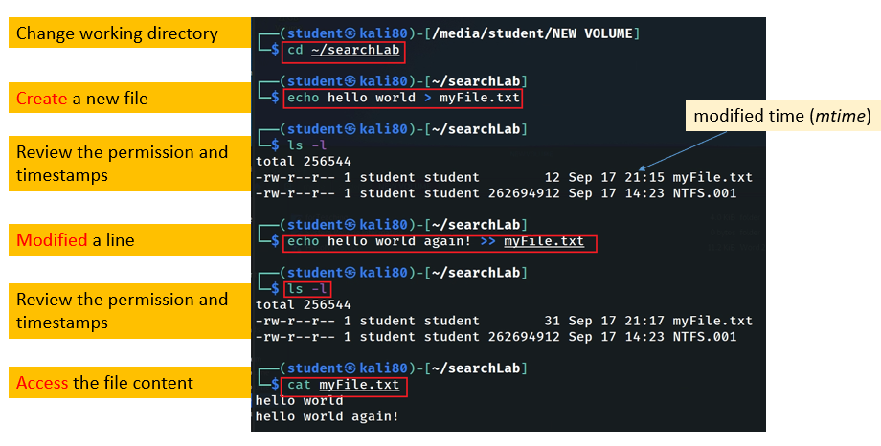
Can you recreate the file changing history? Answer and explaine
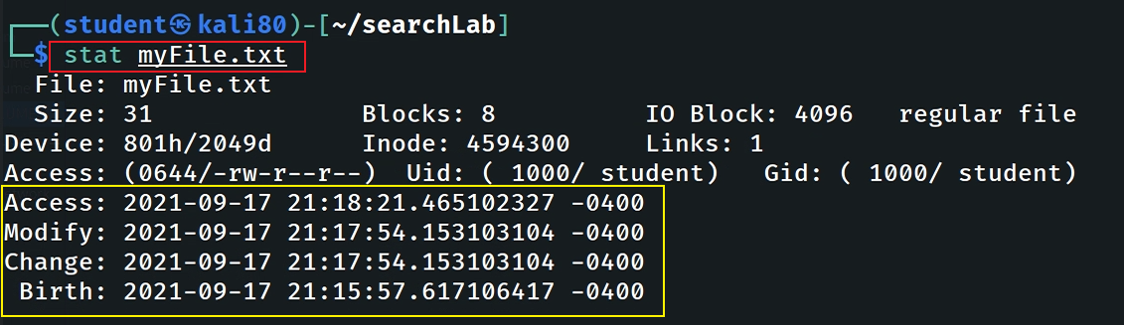
Answer

- Timestamp changes when changing permission
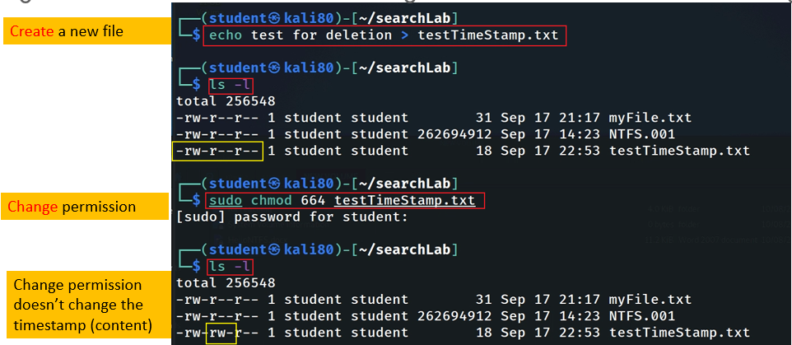

Find Files With “–perm=664” Permissions ?
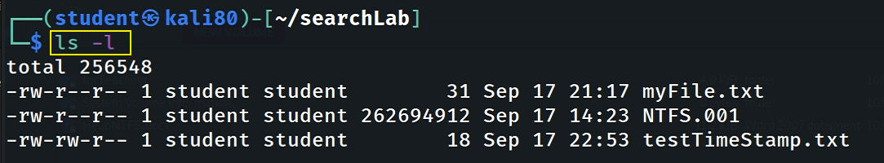
Answer

Find Files With /u=r /u=w /u=x Permissions
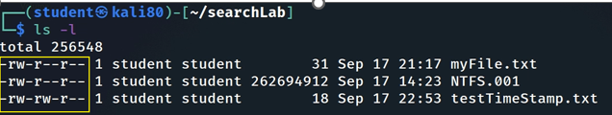
Answer

Find Changed Files in Last 1 Hour ?
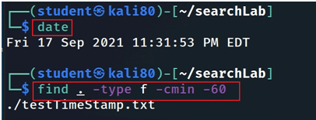
Answer

Find Accessed Files in Last 1 Hour ?
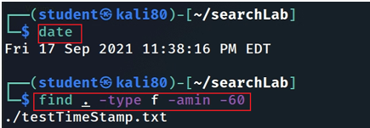
Answer

Find files that size that is great than 10MB ?
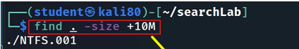
Answer

YOU MUST SUBMIT A FULL-SCREEN IMAGE FOR FULL CREDIT!
Save the document with the filename "YOUR NAME Lab 10.pdf", replacing "YOUR NAME" with your real name.
Email the image to the instructor as an attachment to an e-mail message. Send it to: xxx@fe.edu.vn with a subject line of "Lab 10 From YOUR NAME", replacing "YOUR NAME" with your real name.

